**Project Limitations:**

* **Technical Limitations:**

1. The model uses an open-source model agent as a base
2. An internet connection is required to use Quiz AI which limits it’s target as only 67.9% of the total world population has internet access

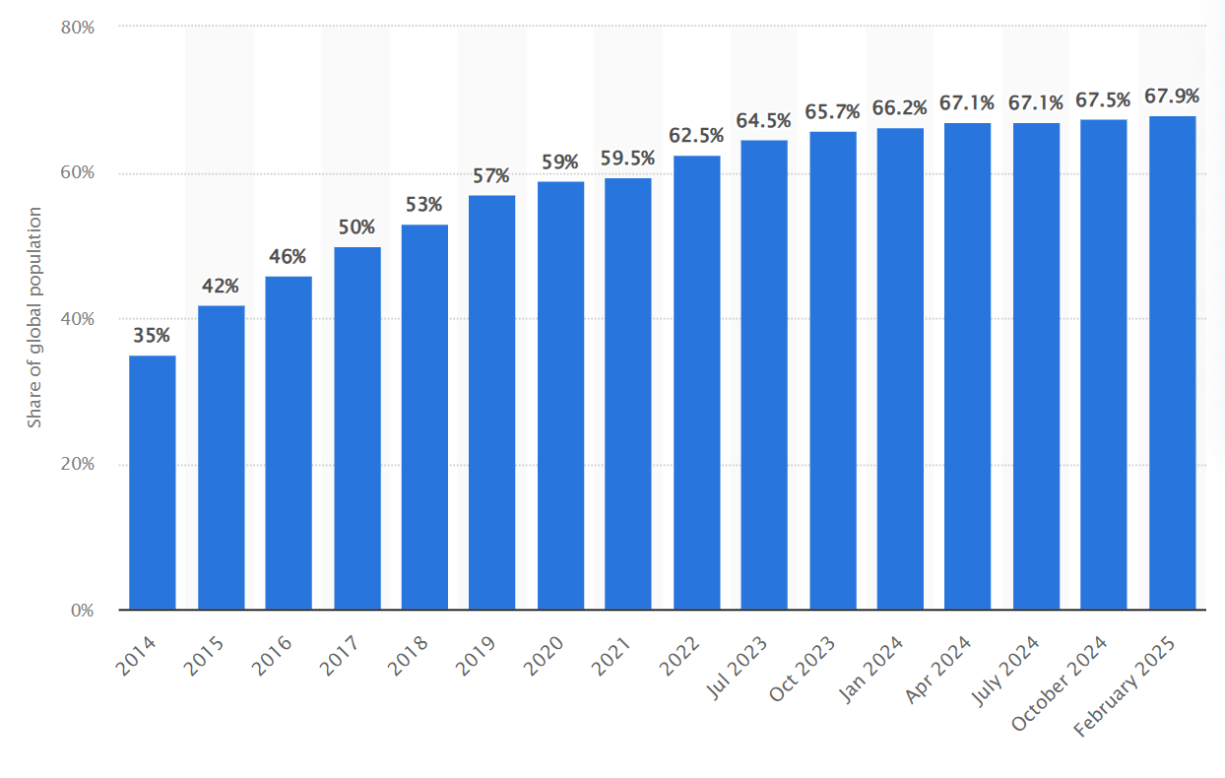

1. There is no application version of Quiz Ai which means it will not be as attractive to use as an app to most of the population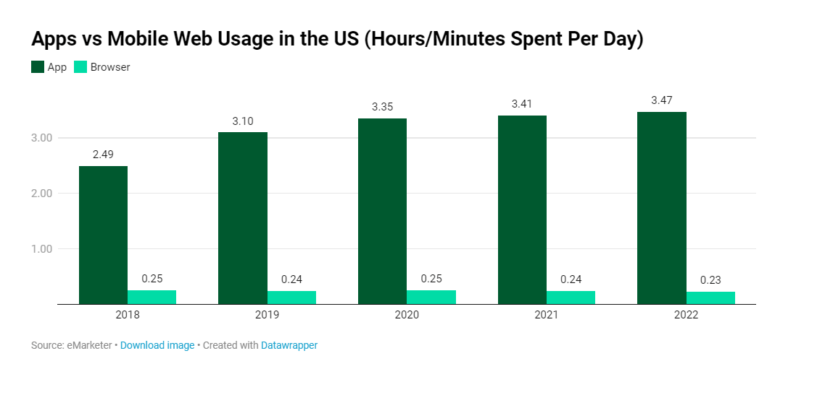

* **Functional Limitations:**

1. Unsupported Features:

extracting audio from video is not implemented

1. Workarounds:

using a third-party API to achieve the operation

* **Security Limitations:**

1. Currently no security measures have been planned for the log-in system
2. The system doesn’t have encryption for the login-database

* **Usability & Accessibility:**

1. The end-user can only submit files in the following formats: (txt , pdf , pptx ,mp3)

* **References:**
* Internet Access Statistics (2025 Projections):
* ITU (International Telecommunication Union) – Global internet penetration data:

<https://www.itu.int/en/ITU-D/Statistics/Pages/stat/default.aspx>

* World Bank Digital Development – Reports on global connectivity gaps:

<https://www.worldbank.org/en/topic/digitaldevelopment>

* GSMA Mobile Economy Report – Mobile internet trends:

<https://www.gsma.com/mobileeconomy/>

* Statista – Internet user forecasts:

<https://www.statista.com/statistics/617136/digital-population-worldwide/>

**Project Expected Output:**

* Functional Outputs:

1. A responsive web dashboard for real-time visualization.
2. On website Notification for when the output is being proceed
3. On website Notification for when the output is finished being proceed

* **Non-Functional Outputs:**

1. A relatively fast output time based on the data inputted
2. A 4 chapters worth of project documentation in the PDF format
3. A GitHub repository containing the source code of the project and its documentation